|  |  |  |
| --- | --- | --- |
| SCHOOL OF INFORMATION TECHNOLOGY | | |
| NAME: Paul Raynee D. Andres | |  |
| SECTION: IDC1 | DATE SUBMITTED: |

# SYSADM

**Table of Contents**

|  |  |  |
| --- | --- | --- |
| **Name of Activities** | **Date of Activity** | **Page No.** |
| **First Grading** | | |
| Quizzes | | |
|  |  |  |
|  |  |  |
|  |  |  |
| Other Activities | | |
| **FGE_LW1 Creating File Systems** | 08/21/2024 |  |
| **FGE_System Administration: From Manual To Automated** | 08/20/2024 |  |
| **FGE_Organizational Policies** | 08/27/2024 |  |
| **FGE_LW4 Managing Services in Linux** | 09/11/2924 |  |
| First Grading Exam | 09/17/2024 |  |
| **Midterms** | | |
| Quizzes | | |
|  |  |  |
|  |  |  |
|  |  |  |
| Other Activities | | |
| **M_LW1 Print Services** | 09/25/2024 |  |
| **M_LW2 Web Server** | 10/09/2024 |  |
| **M_R1 Web Server Monitoring** | 10/16/2024 |  |
| Midterm Exam | 10/29/2024 |  |
| **Finals** | | |
| Quizzes | | |
| **FQuiz1_Recovery** | 11/20/2024 |  |
|  |  |  |
|  |  |  |
| Other Activities | | |
| **FLW1_Kerberos (1)** | 11/13/2024 |  |
| **FLW1_Kerberos** | 11/06/2024 |  |
| **FL_DATA LOSS** | 11/19/2024 |  |
| **FLW2 Git** | 11/20/2024 |  |
| Final Exam |  |  |
| Course Reflection |  |  |

**<insert your scanned activities here include title>**

**PRELIMS:**

**FGE_LW1 Creating File Systems:**

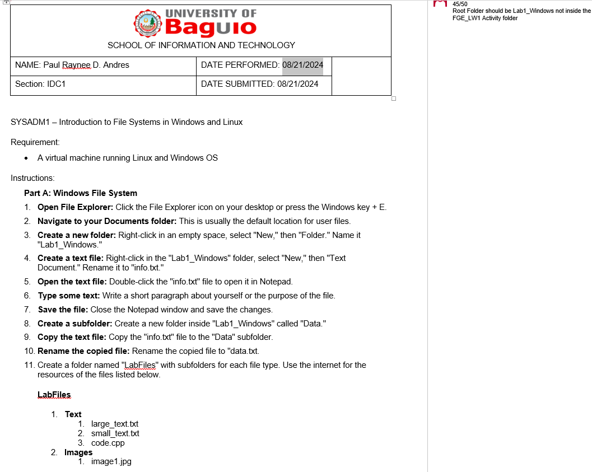

**FGE_System Administration: From Manual To Automated:**

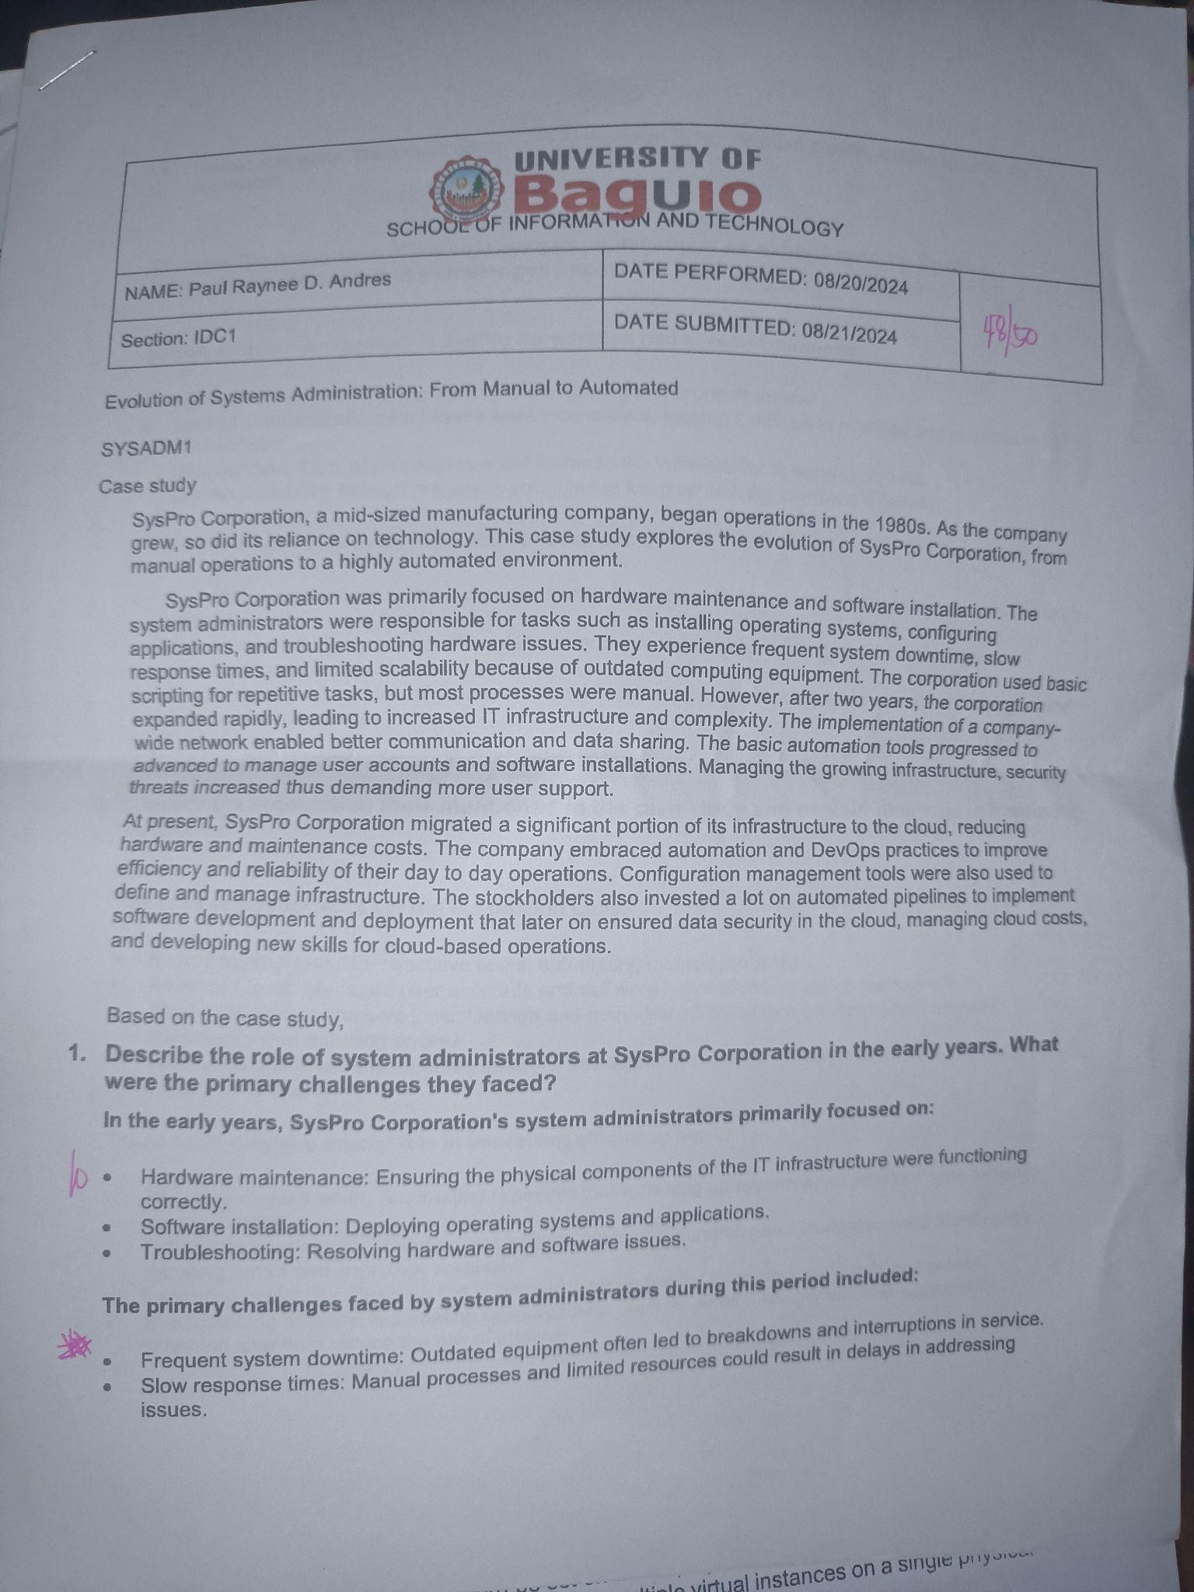

**FGE_Organizational Policies:**

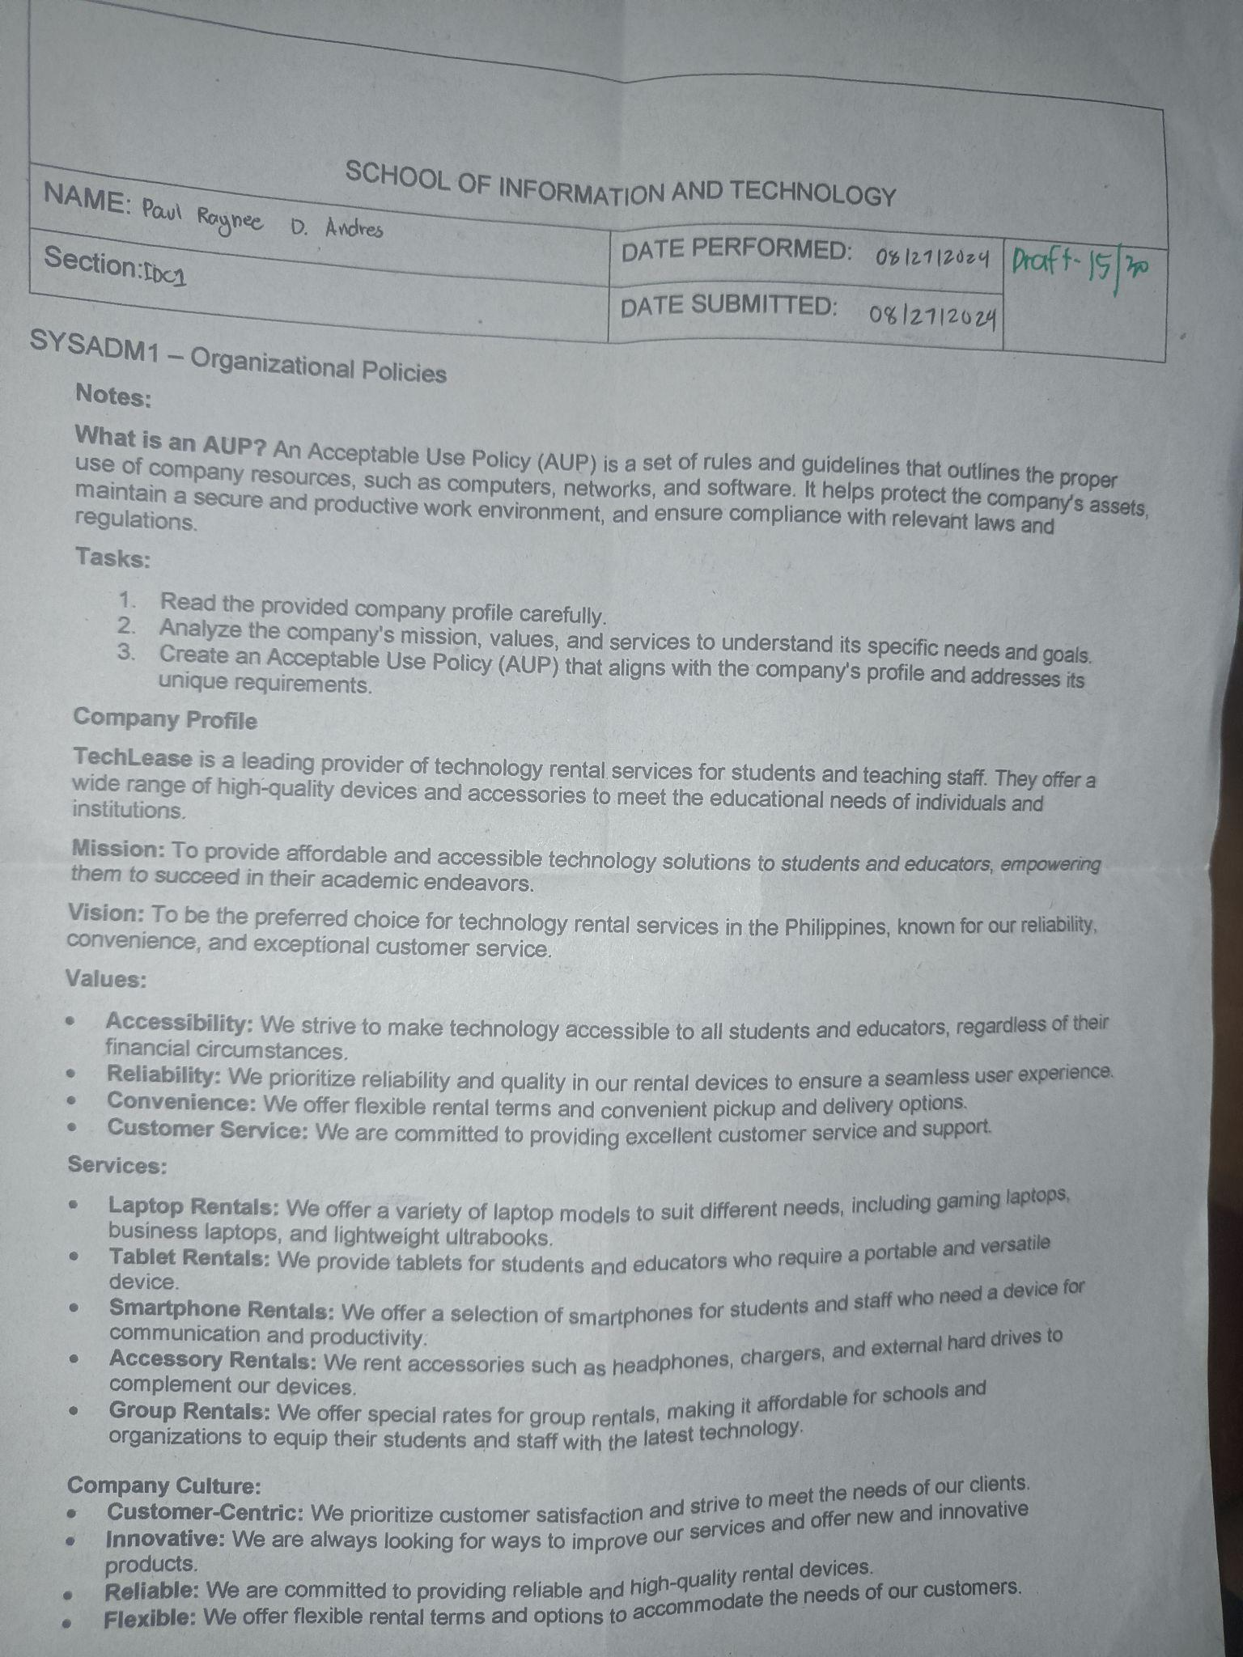

**FGE_LW4 Managing Services in Linux:**

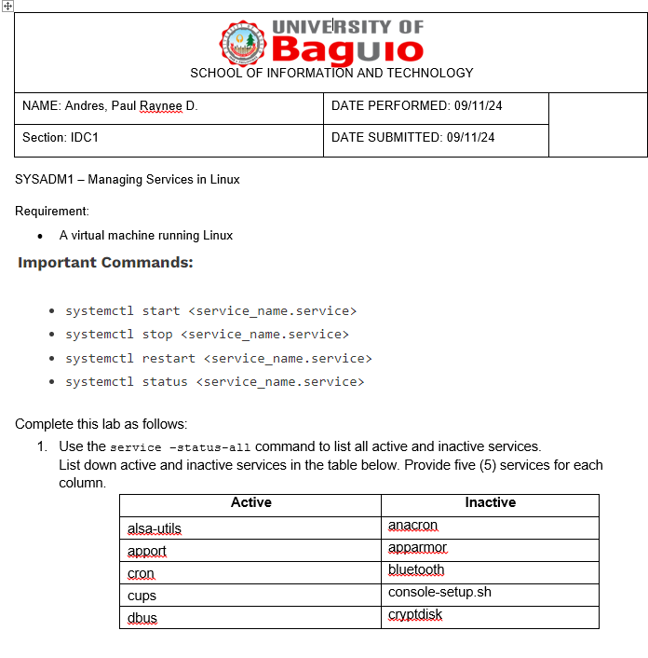

**First Grading Examination:**

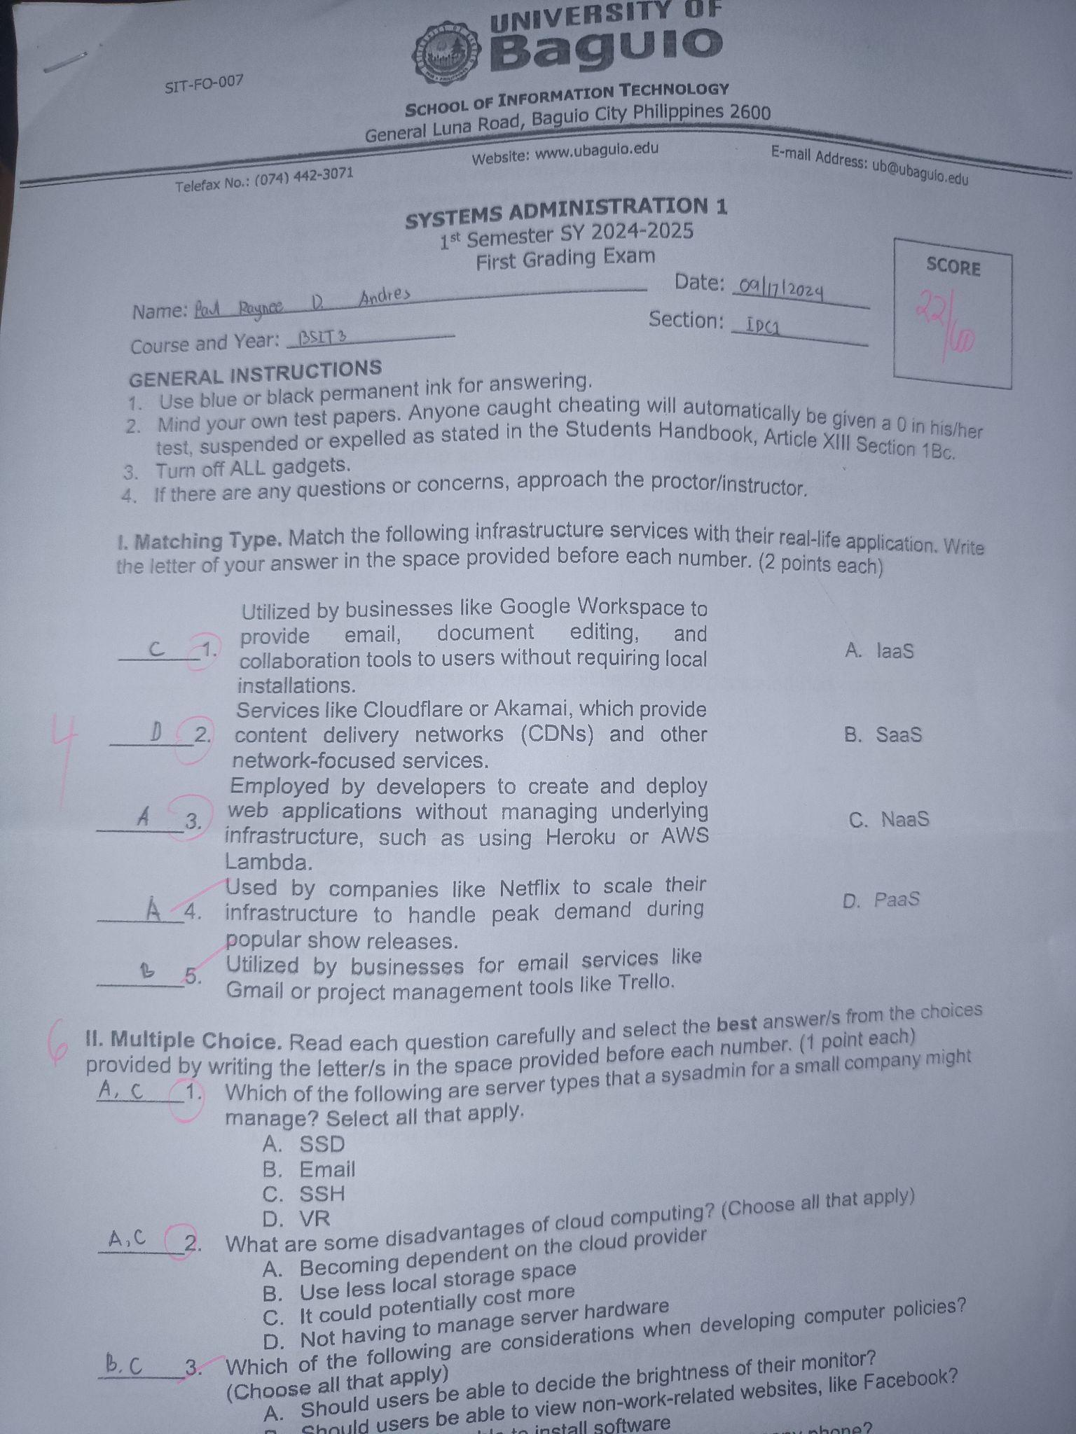

**MIDTERMS:**

**M_LW1 Print Services:**

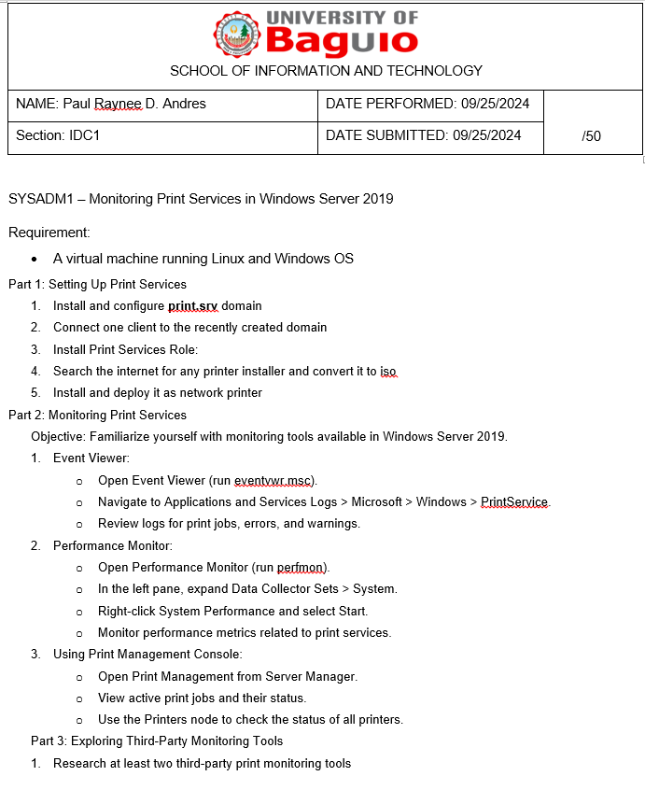

**M_LW2 Web Server:**

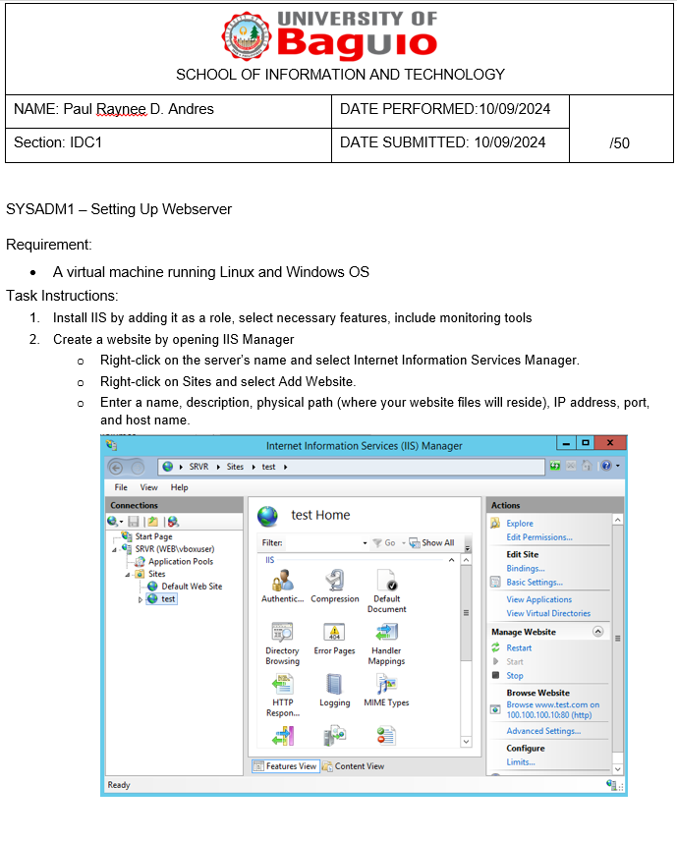

**M_R1 Web Server Monitoring:**

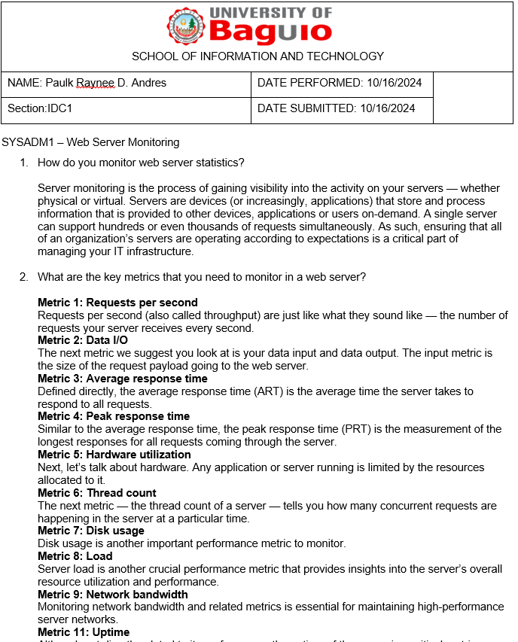

**Midterm Examination:**

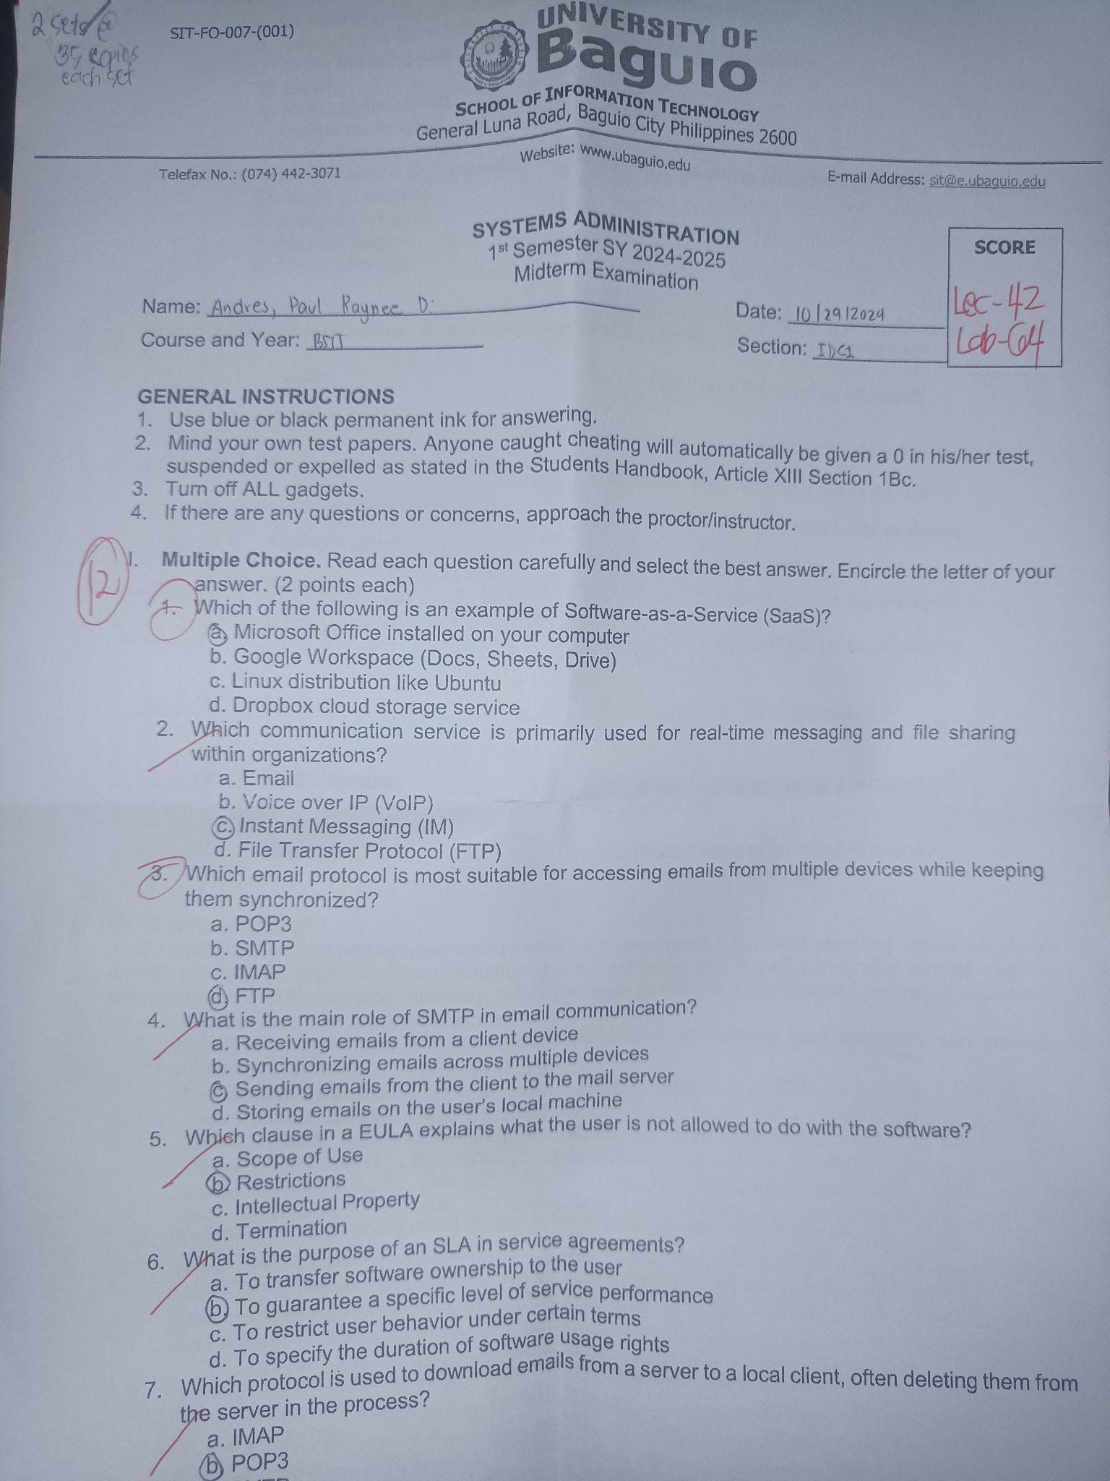

**FINALS:**

**FQuiz1_Recovery:**

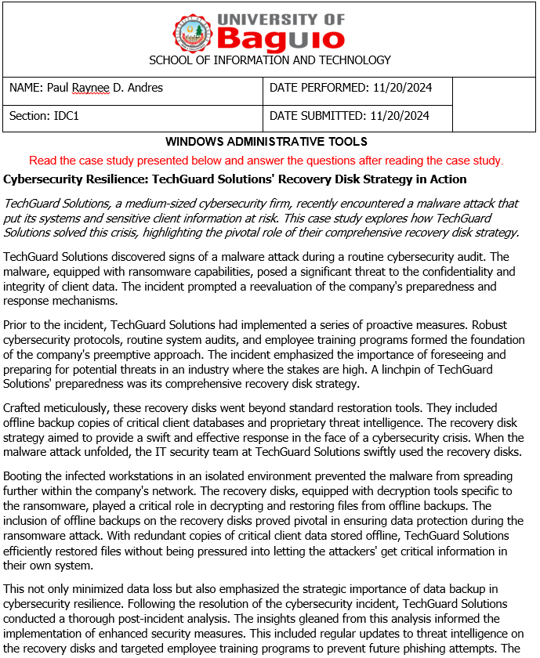

**FLW1_Kerberos (1):**

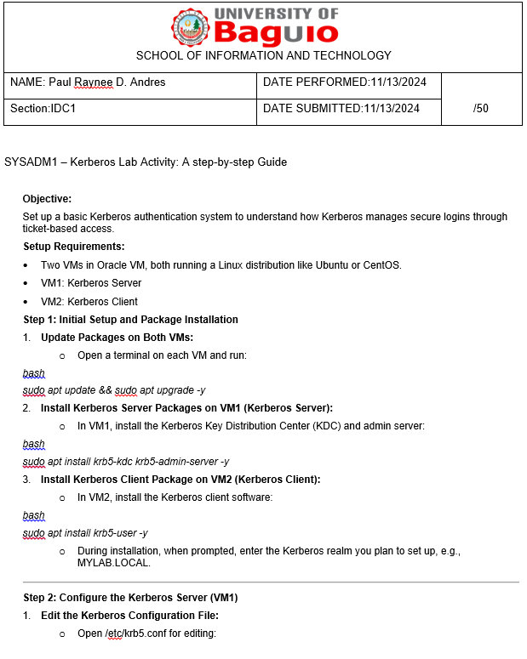

**FLW1_Kerberos:**

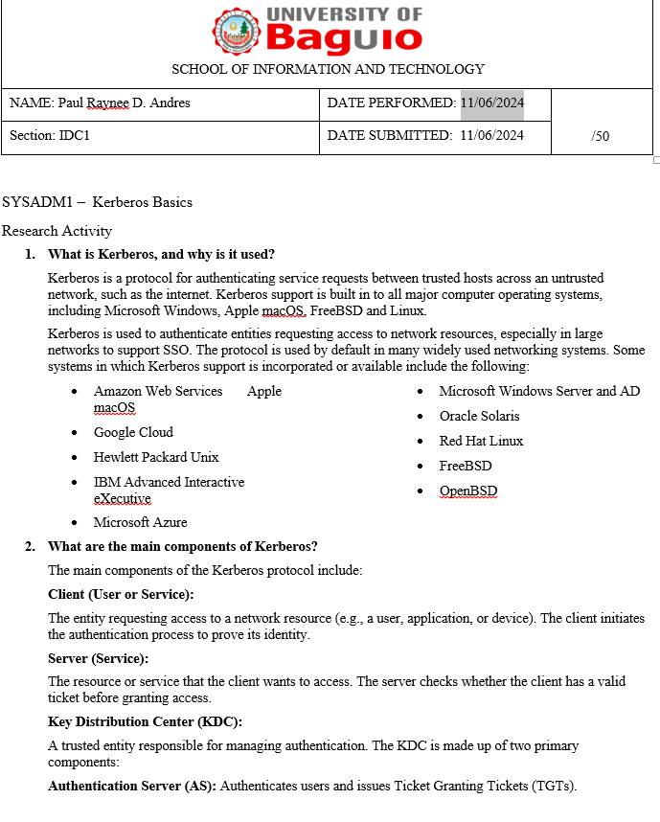

**LW_DATA LOSS:**

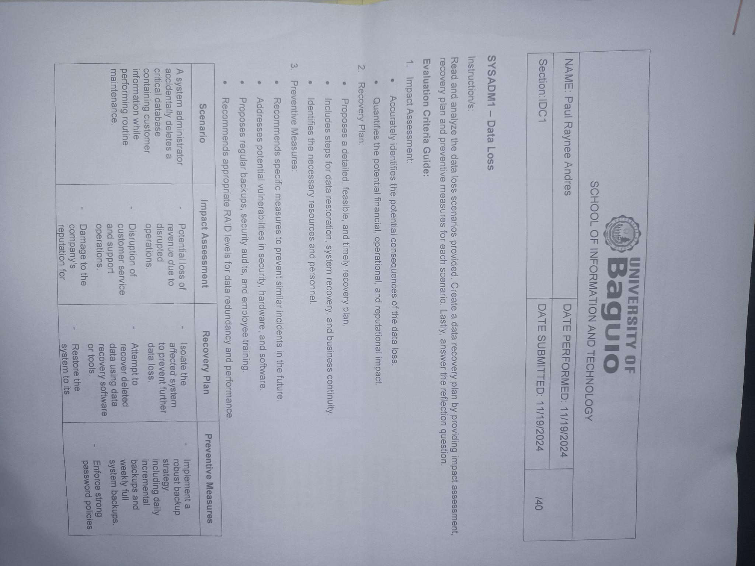

**FLW2 Git:**

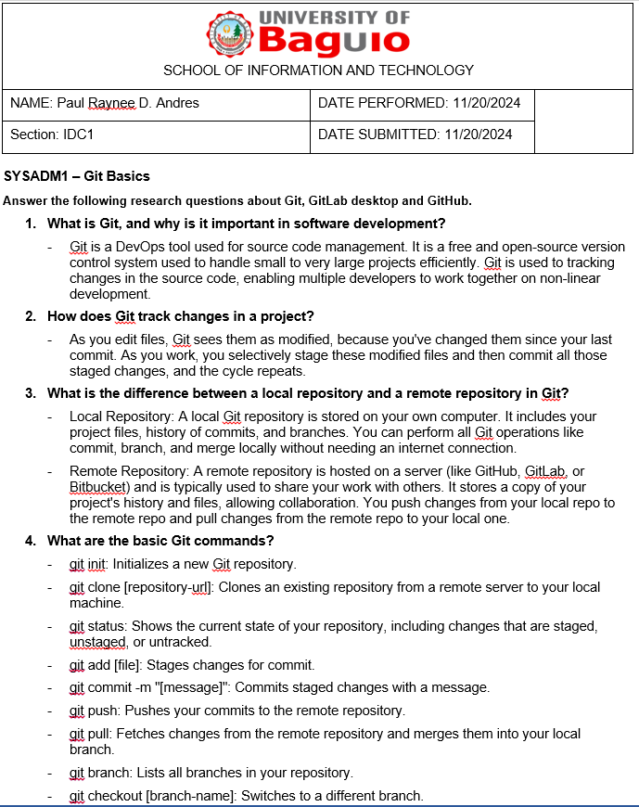

**Course Reflection**

What were your initial expectations for the course? Did the course meet, exceed, or fall short of these expectations?

|  |
| --- |
| I anticipated gaining a foundational understanding of system administration principles, including server management, network configuration, user administration, and basic troubleshooting techniques, and hoped to develop practical skills applicable in real-world IT environments. The course generally met my expectations by providing a solid grasp of core concepts and hands-on experience through practical exercises and simulations. |

What were the main topics or concepts covered in the course? How did these topics contribute to your understanding of the subject matter?

|  |
| --- |
| The course covered key topics like operating systems, networking, server setup, security, scripting, and virtualization. These topics helped me understand how computer systems work together and how to manage them. |

Reflecting on your learning process, what were the most effective strategies or techniques that helped you grasp and retain the course material?

|  |
| --- |
| Hands-on practice, active learning techniques like note-taking and summarizing, and regular review of course materials proved most effective in grasping and retaining the material. |

Were there any particular assignments, projects, or activities that significantly enhanced your learning experience? Why were they effective?

|  |
| --- |
| Hands-on labs simulating real-world scenarios, such as configuring a web server or setting up a firewall, were highly effective. Projects involving designing and implementing a small network or configuring a specific server service provided an opportunity to integrate learned concepts and develop a deeper understanding. Group discussions and peer learning fostered a deeper understanding and provided different perspectives. |

Did you encounter any challenges or difficulties during the course? How did you overcome these obstacles, and what did you learn from them?

|  |
| --- |
| Technical difficulties, staying updated with evolving technologies, and time management were some of the challenges faced. Overcoming these obstacles required patience, problem-solving skills, independent research, continuous learning, and effective time management. |

Did the course encourage critical thinking and analysis? How did it promote higher-order thinking skills, such as problem-solving or decision-making?

|  |
| --- |
| The course emphasized critical thinking and analytical skills by presenting real-world scenarios requiring careful analysis, diagnosis, and effective solutions. It also encouraged decision-making by evaluating different options and making informed decisions based on factors like performance, security, and cost. |

Reflecting on your personal growth, what new knowledge, skills, or perspectives did you gain from this course?

|  |
| --- |
| I gained a strong foundation in operating systems, networking, and server administration, developed practical skills in server configuration, troubleshooting, and scripting, and honed my problem-solving and analytical skills. Working on group projects also improved my communication and collaboration skills. |

How do you plan to apply what you have learned in this course to your future studies, career, or personal life?

|  |
| --- |
| The knowledge and skills gained will be invaluable for further studies in computer science, such as cybersecurity, cloud computing, or network engineering. This course has provided me with the foundational knowledge and skills necessary for a career in system administration or related IT roles. Furthermore, the understanding of computer systems and networking will be beneficial for managing personal devices, troubleshooting issues, and understanding how technology works in everyday life. |